Project Development Phase
Performance Test

Date | 10 February 2026
Team ID | desaisabiha1212@gmail.com
Project Name | Online Food Delivery using Tableau
Maximum Marks

Project Performance Testing:
Project team shall fill the following information in model performance testing template.
S.No. | Parameter | Screenshot / Values
 | Data Rendered | Tableau Data Source – Dataset  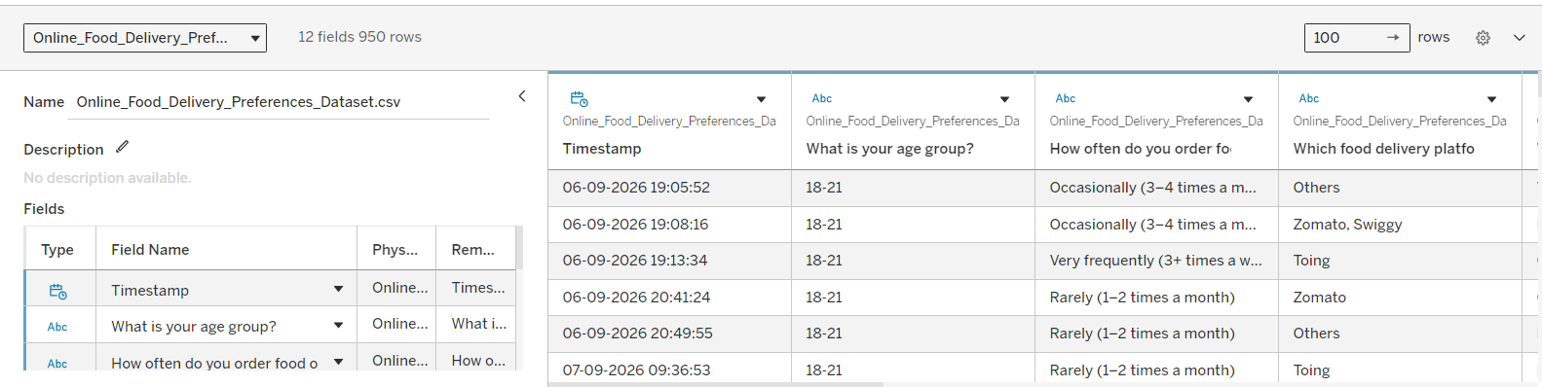
 | Data Preprocessing | Data Source / Data Cleaning
3. | Utilization of Filters | Dashboard Filters  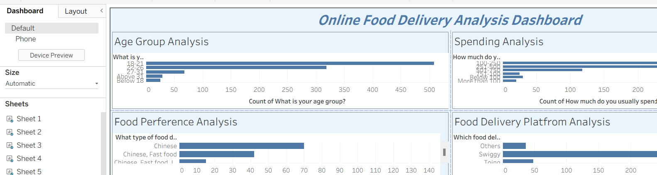
4. | Calculation fields Used | Calculated Fields  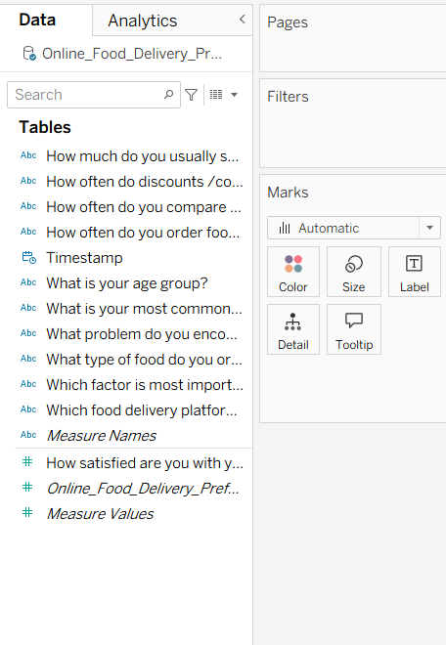
5. | Dashboard design | No of Visualizations / Graphs - All 3 Dashboards-  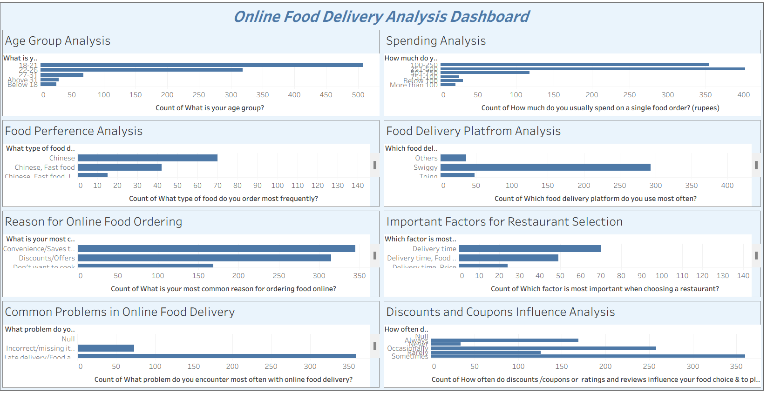  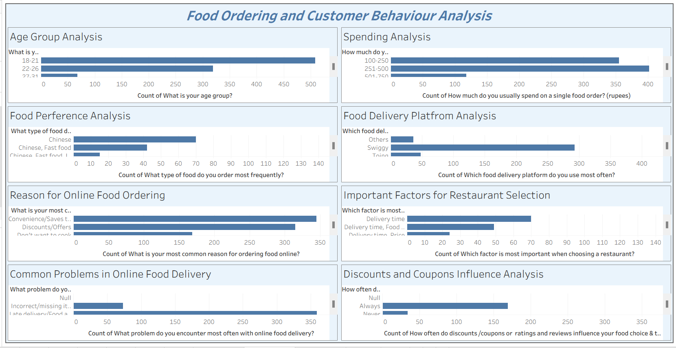  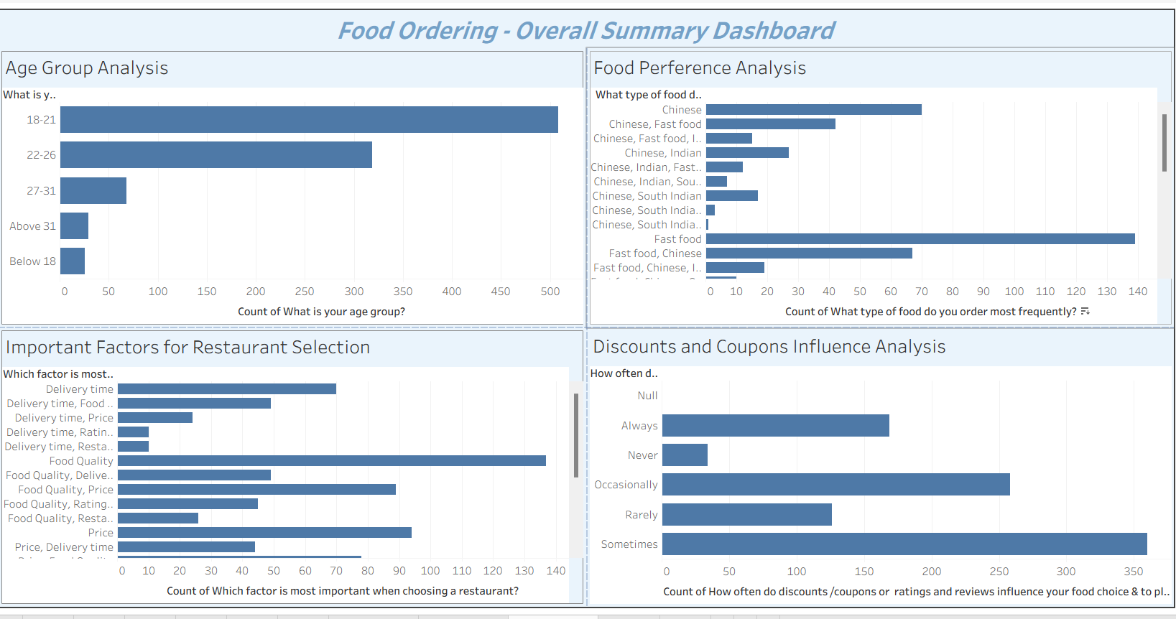
6 | Story Design | Tableau Story-  

